Computer Vision Pipeline Used by TESLA
Introduction:
Tesla is a company known for its self-driving cars. The cars here work based on Artificial Intelligence (AI) & Computer Vision (CV) to understand the path and drive automatically.
AI is a technique that helps machine mimic human brain and then solve problem and reasoning.
CV is a technique which helps machine understand images, videos, just like humans do.
Tesla uses camera instead of sensors (like LiDAR). These cameras capture videos of the surrounding and helps the AI model understand all kinds of activities happening around.
Tesla works using a computer vision pipeline which is as follows:

1. Collection of Data:
The first step is to collect the car data using camera. Tesla has 8 cameras in total that captures 360 degrees view.
The data consists of following features: Roads, other vehicles, Traffic lights, Lane markings, Road signs, etc.
All these data help the system understand the environment.
Why does Tesla use 8 cameras?
Tesla uses 8 cameras for 360 degrees coverage – 3 forward, 2forward-side, 2rear-side, 1 rear. This handles close obstacles to 250m highway views. These cameras are 1.2 MP CMOS sensors with low-light/high dynamic range & forward facing with vary focal length.
Why camera instead of LiDAR?
Cameras are cheaper, scalable to million cars.

2. Storage of Data and Loading:
Second step is to send the important data to Tesla Servers.
The uploaded data includes:
Short video clips
Driving information
Unusual incidents (accidents, sudden breaks, etc)
This helps Tesla understand real driving scenarios and difficult driving situations- helps improve the AI model. This data is used to train the models.
Why upload short clips to servers?
Captures rare-edge cases for targeted retraining.

3. Data Labelling (Annotation):
Before training the model, the data is labelled. These labels include drawing a bounding box, marking pedestrians, identifying traffic lights, Detecting Lane markings.
These images help the system understand: Car, Truck, Pedestrian, traffic signals, road lane, etc.
4. Training of AI models:
Tesla uses the labelled data to train deep learning models; these models learn patterns from the large Datasets.
Tesla uses powerful computers and GPUs to train these models.
Tesla also has developed powerful training system called Dojo.
The AI model learns to recognize:
Roads and lane boundaries
Cars and trucks
Pedestrians and cyclists
Traffic lights and signals
Distance between objects
As more data is feeded into the model- it gets better understanding of roads.
Why build Dojo supercomputers?
It is good for petabyte video, trains FDS 5-10x faster/cheaper than GPUs, it handles exaFLOP vision tasks.

5.Perception understanding the environment):
These trained models are used inside Tesla vehicles, the system processes camera image and tries to understand the surrounding environment.
Then AI converts these images into a 3D understanding of road, often shown from bird’s eye view, The system detects:
Lane markings
Nearby cars
Pedestrians
Traffic lights
Road edges
This helps the car understand what is happening around it.
How does bird’s eye view perception work?
Fuses the feed from 8 cameras into a 3D overhead map via neural nets and then estimates its path/trajectories for path planning and therefore no LiDAR needed.
6. Prediction and Decision Making:
In this step the AI tries to predict the movement of the nearby vehicles & objects
For example:
Will a pedestrian cross the road?
Will a car change lanes?
Will the traffic light turn red?

After predicting these possibilities, the system decides what action to take.
Possible decisions include:
Slow down
Stop the car
Change lanes
Continue driving
These decisions happen very quickly.

7. Planning and Vehicle control:
The final step is taking decisions, for this the system sends commands to the vehicles control system.
These commands control:
Steering wheel
Brakes
Acceleration
For example:
Turn the steering wheel to stay in the lane
Apply brakes if a pedestrian appears
Accelerate when the road is clear
This is how the Tesla car drives automatically using AI and computer vision.
Why continuous software updates?
Improves model overtime using fleet data and so no hardware change is needed.

Conclusion:
Tesla follows a strong CV pipeline to support autonomous driving.
From data collection to its storage, labelling and using it for training models. These models help the car to understand the environment through a process called perceptron.
After the understanding of surrounding the system predicts the movement of the objects and decides the safest root.
One of the advantages for Tesla is that they have a large data source collected from Tesla vehicles worldwide and based on this the model keeps learning and tries to improve its performance.
As AI and computer vision technologies continue to improve, Tesla’s approach may play an important role in the future of fully autonomous transportation.

Advantages:
- Use of cameras instead of expensive sensors
Many companies use expensive sensors, but tesla uses cameras which makes it cost effective and scalable.

- Large amount of data for training
Tesla vehicles are used by millions of people around the world. These cars continuously collect driving data, which helps Tesla train and improve its models.
More data helps the system learn from different weather conditions, road types, and traffic situations.

- Continuous improvement through updates
Tesla regularly releases software updates to improve the performance of the autonomous driving system. This means the system can become better and safer over time without changing the hardware.

- Human like driving approach
Since Tesla relies on cameras, the system works in a way like human vision, where decisions are made based on what the car sees on the road.

Limitations:
- Difficult weather conditions
Camera can have difficulty in conditions like heavy rain, fog, snow, low lighting, etc

- Complex Road conditions
Some paths are unpredictable like construction zones, unusual traffic behaviour, poor road markings.

- Safety and regulation
Regulations vary country to country

- Need for continuous model training
As driving environments tend to change overtime, tesla should keep training and updating its model.

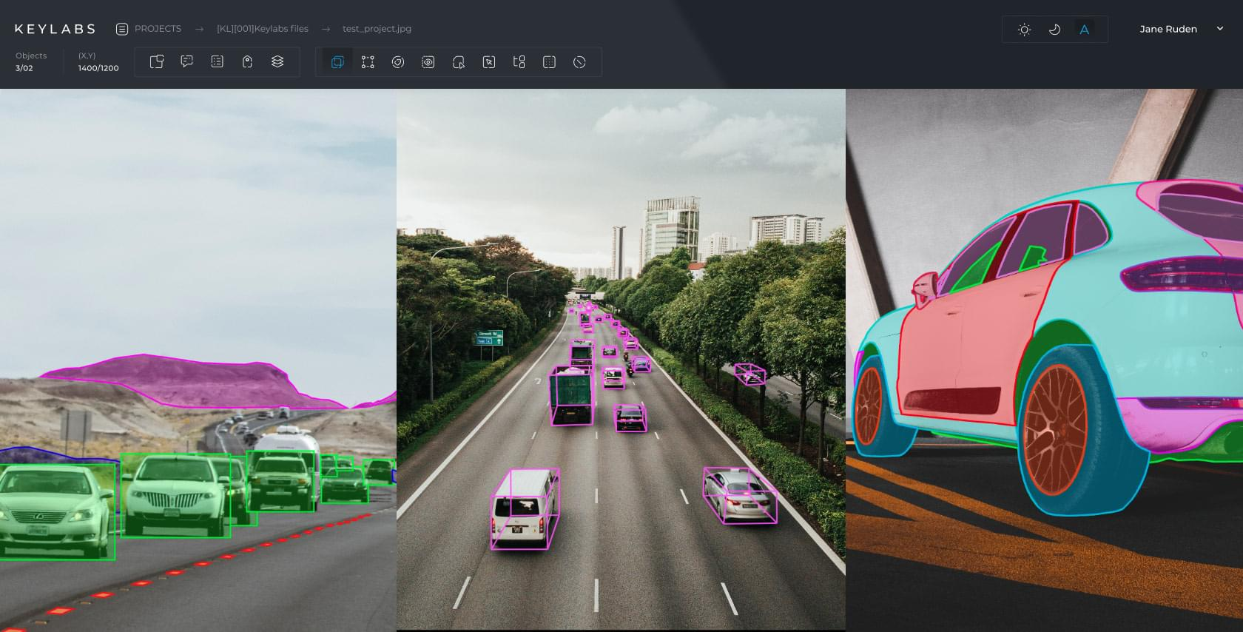

Computer Vision Object Detection
(Good for Data Annotation / Model Training section)

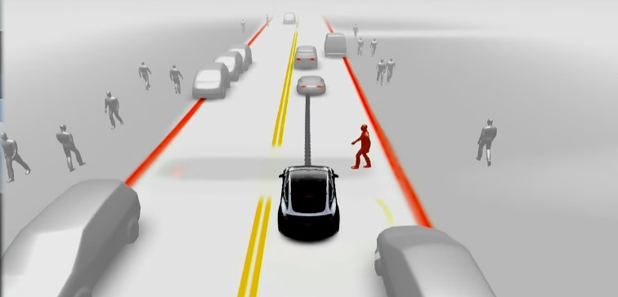
Tesla Bird's Eye View Perception
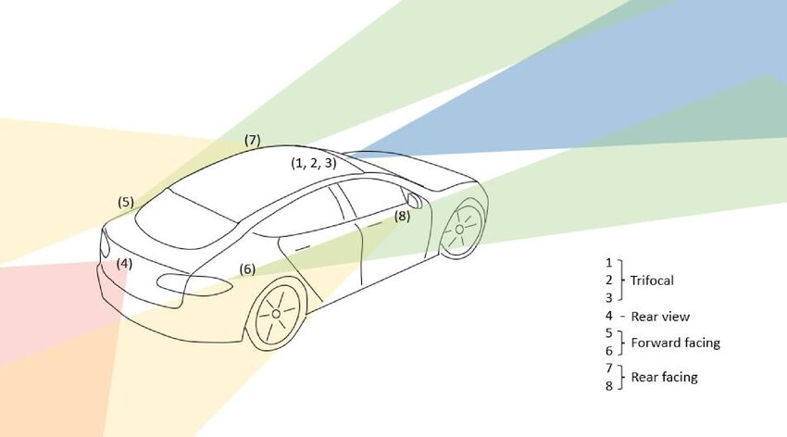
Tesla Autopilot Camera System
(Good for Data Collection section)
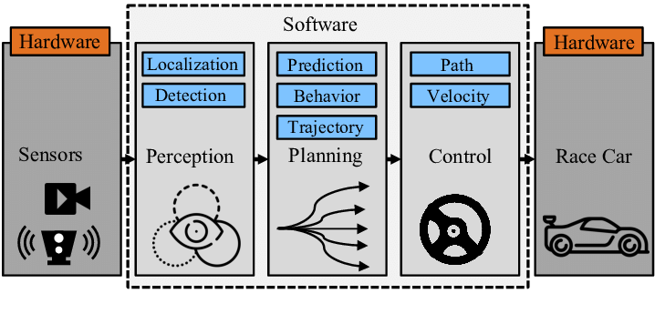
Autonomous Driving Pipeline Diagram

